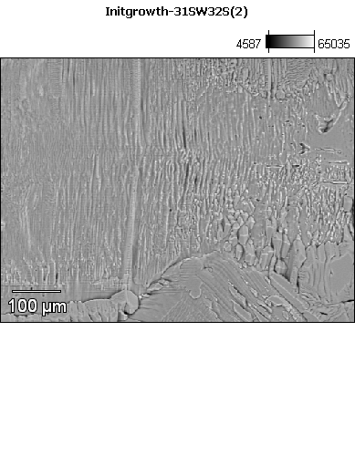

Data Type: Counts

Image Resolution: 512 by 384

Image Pixel Size: 1.46 µm

Map Resolution: 256 by 192

Map Pixel Size: 2.91 µm

Acc. Voltage: 14.0 kV

Magnification: 170

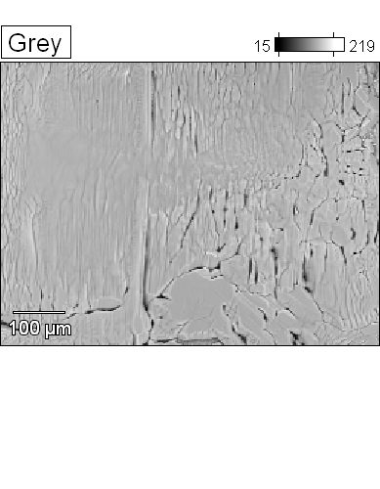 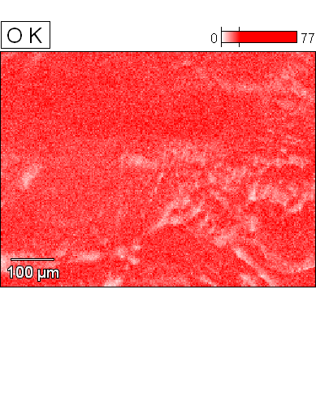



Data Type: Counts

Image Resolution: 512 by 384

Image Pixel Size: 1.46 µm

Map Resolution: 256 by 192

Map Pixel Size: 2.91 µm

Acc. Voltage: 14.0 kV

Magnification: 170

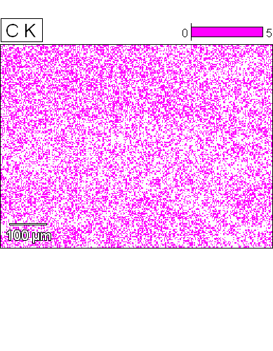 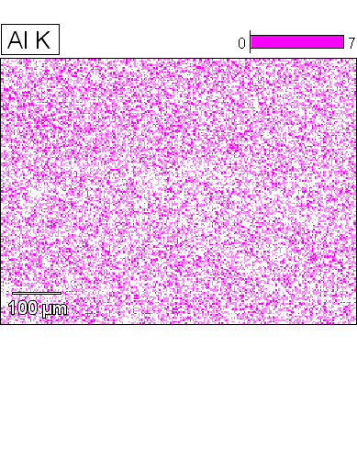



Data Type: Counts

Image Resolution: 512 by 384

Image Pixel Size: 1.46 µm

Map Resolution: 256 by 192

Map Pixel Size: 2.91 µm

Acc. Voltage: 14.0 kV

Magnification: 170

